Raspberry Pi Project 2– Sonic Pi

Objective: Use Sonic Pi to compose custom doorbells or ringtones.

# Overview:

Sonic Pi is a program that comes pre-loaded on the Raspberry Pi that allows you to compose music using a text file. You are able to play notes on a keyboard by typing “play” followed by a number from 21-108. To make a pause after playing a note, you can then use “sleep” followed by a decimal representing time in seconds. Also, you can play certain notes in a loop by starting with “x. times do” (x representing the number of times to repeat), followed by the notes/pauses you want repeated, and ending with “end”.

Once you have finished programming your tune, you can press the play button to listen to is. If you want to make changes, you can. If you like it, you can hit record and play it again; once the tune stops, press record again. This will bring up a prompt asking you what you want to name your audio file and where you would like to save it too. It will save it as a .wav file by default.

## Doorbell

This is just a simple doorbell that plays two notes with a sleep (pause) of 1 second before the second one plays.

## Tune 1

By completing the challenges on the raspberry Pi Project website for this project, I came up with a more complex tune that plays more notes and loops.

However, I still wasn’t satisfies, so I made one more song (see below)

## “Legend of Zelda – Song of Time” Ringtone

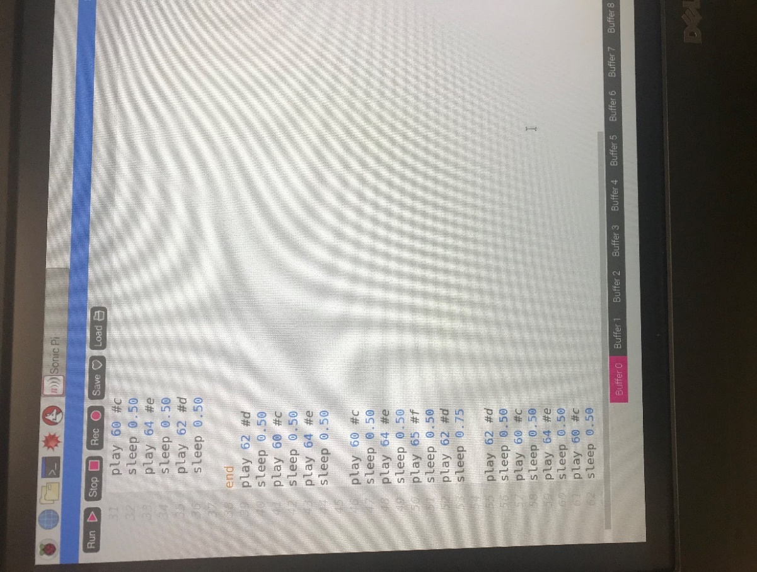

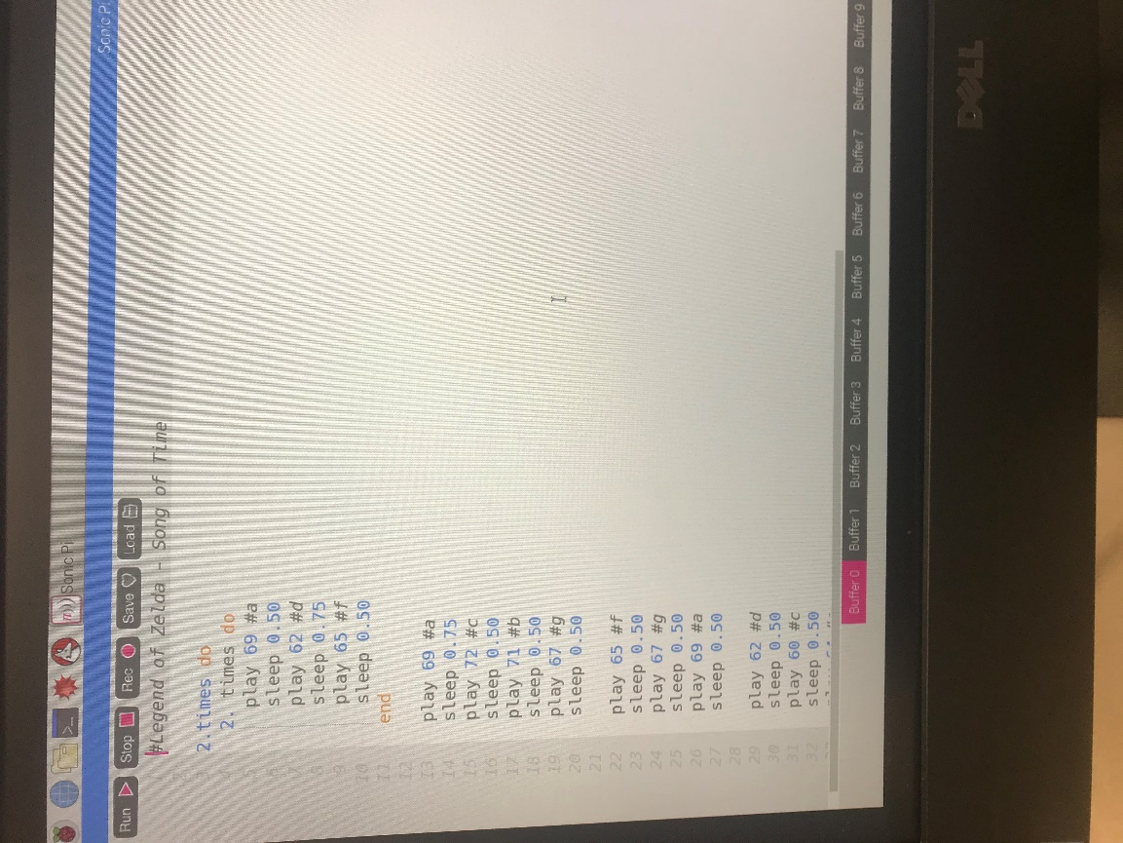

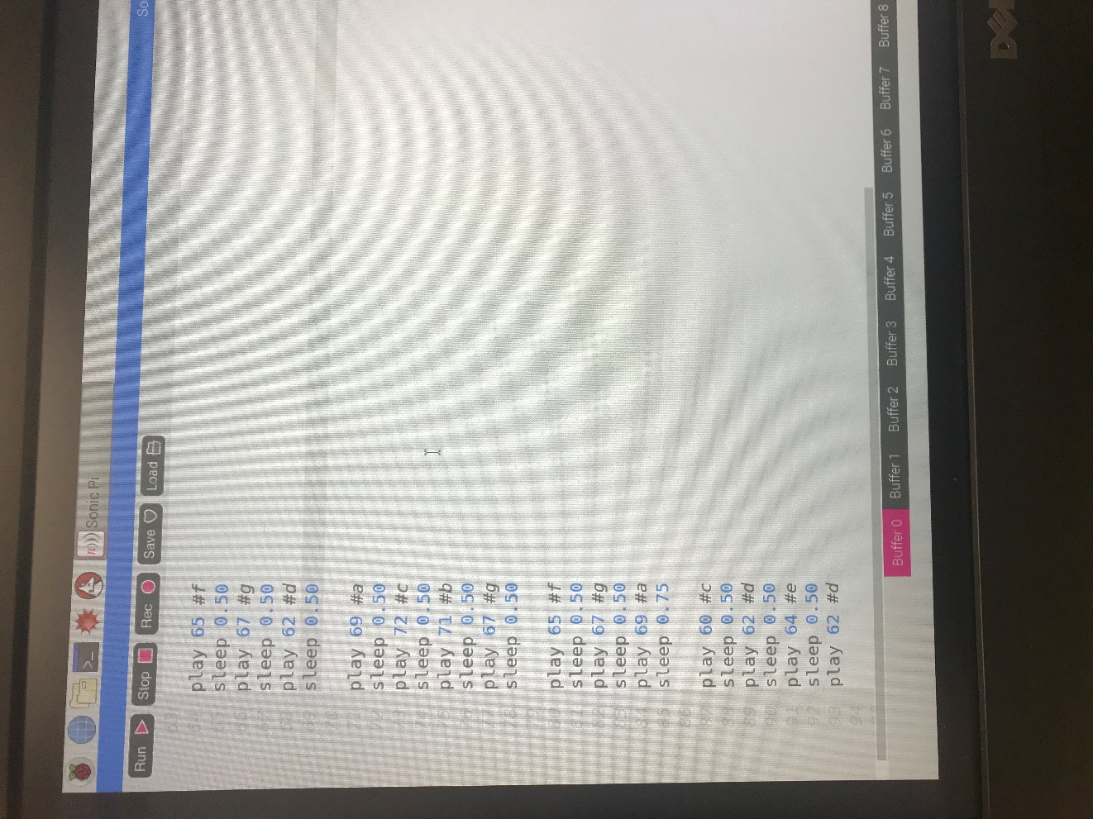This song was quite a bit more challenging. I am not really musically gifted or knowledgable, so I looked up a Youtube tutorial of how to play this song on the keyboard. I then figured out which notes to play in the correct order.

After I knew what the notes were, I had to determine what numerical values matched them, and I just commented out the notes.

As you can see the first part of the song is repeated twice, so I used a loop from lines 3-38. Inside of that part, the first three notes are repeated as well , so I used another loop from lines 4-11.

The hardest part of this was figuring out the timing. I am not sure what the actual time scheme of this song is, so I had to just guess, listen to it, and then adjust. I realized towards the end that it was a bit to slow, so I decrease all of the sleep values by 0.25. It sounds much better, but again, I can’t guarantee that it is 100% accurate. While it looks like a lot of notes are being played, especially with the loops, the audio is only about 30 seconds total.

## Attached

I am also going to include the individual text files and the .wav files in my submission, in case you wish to inspect those as well.